**UNIVERSITI TUNKU ABDUL RAHMAN**

**LEE KONG CHIAN FACULTY OF ENGINEERING AND SCIENCE**

**UECS2344 SOFTWARE DESIGN**

**ASSIGNMENTS (Part 1, Part 2(a) and Part 2(b))**

**January 2024 Trimester**

|  |  |  |  |
| --- | --- | --- | --- |
| **NO.** | **STUDENT NAME** | **STUDENT ID** | **Practical Group** |
| **1.** | **Low Si Qing** | **2104872** | **P3** |
| **2.** | **Kuik Rui Luan** | **2103790** | **P3** |
| **3.** | **Vincy Lim Wei Jun** | **2105978** | **P6** |
| **4.** | **Zoe Chua Zi Yi** | **2103816** | **P3** |

**Table of Contents**

**Analysis Class Diagram** 3

**Use Case Diagram** 4

**Use Case Descriptions** 5

UC01 5

UC02 6

UC03 8

UC04 9

UC05 11

UC06 13

UC07 17

UC08 19

UC09 23

**Sequence Diagram** 24

**Structural View** 24

**UC01 Log in account** 28

**UC02 Create Profile** 32

**UC03 View item list** 34

**UC04 Create order** 35

**UC05 View order** 39

**UC06 Update order** 41

**UC07 Make payment** 48

**UC08 Manage Item** 51

**UC09 Generate report** 58

**Design Class Diagram** 69

**1st Version of Design Class Diagram** 69

**2nd (Final) Version of Design Class Diagram** 70

**Package Diagram** 71

# **Analysis Class Diagram**

# **Use Case Diagram**

# **Use Case Descriptions**

|  |  |  |  |
| --- | --- | --- | --- |
| Use Case Name: Log in account | | ID: UC01 | Importance Level: High |
| Primary Actor: Administrator, Client user | Use Case Type: Detail, Real | | |
| Stakeholders and Interests:  N/A | | | |
| Brief Description: This use case describes how an administrator or a client user can login into the system by providing the system their username and password to access the system. | | | |
| Trigger: The administrator or client user wants to access the electronic shop inventory management system. | | | |
| Relationships:  Association : Administrator, Client user  Include : N/A  Extend : N/A  Generalization: N/A | | | |
| Normal Flow of Events:   1. The system asks for the user's username and password. 2. The user provides username and password to the system. 3. The system checks for matching login credentials in the database to proceed. **Perform flow 3.1 or 3.2 or 3.3.**    1. If the provided credentials match the administrator’s login credentials, the system displays administrator's main menu. The use case ends.    2. If the provided credentials match with a client user's login credentials, the system displays client user's main menu. The use case ends.    3. If the provided credentials do not match any combination of username and password, the system prompts the user to re-enter username and password. Continue to **flow no.2.** | | | |
| Sub-flows:  N/A | | | |
| Alternate/Exceptional Flows  N/A | | | |

|  |  |  |  |
| --- | --- | --- | --- |
| Use Case Name: Create profile | | ID: UC02 | Importance Level: High |
| Primary Actor: Administrator | Use Case Type: Detail, Real | | |
| Stakeholders and Interests:  Client users provide their personal information such as username, password, name, email, and phone number to the administrator to create profile. | | | |
| Brief Description: This use case describes how an administrator can create user profile by using the personal information provided by client user. | | | |
| Trigger: The client user wants to register an account to access the electronic shop inventory management system. | | | |
| Relationships:  Association : Administrator  Include : N/A  Extend : N/A  Generalization: N/A | | | |
| Normal Flow of Events:   1. The administrator logs in the system using administrator’s username and password. Execute **UC01 – Log in account**. 2. The system displays a menu of available functionalities. 3. The administrator selects “Create Profile” option from the menu. 4. The system prompts the administrator to enter client user’s personal information, including username, password, name, email, and contact number. 5. The administrator provides the client user’s personal information as requested. 6. The system requests confirmation of action from the administrator. 7. The administrator chooses either to confirm or not confirm the action. 8. The system checks the administrator's choice. **Perform 8.1 or 8.2.**    1. If the choice is "confirm", the system adds the new client user into the database. Continue to **flow no.9**.    2. If the choice is "not confirm", the system displays a message informing the administrator that the client user was not created. Continue to **flow no.9**. 9. The system returns to the administrator's main menu. The use case ends. | | | |
| Sub-flows:  N/A | | | |
| Alternate/Exceptional Flows  1a. The administrator must have a valid login to the system. | | | |

|  |  |  |  |
| --- | --- | --- | --- |
| Use Case Name: View Item List | | ID: UC03 | Importance Level: High |
| Primary Actor: Client User | Use Case Type: Detail, Real | | |
| Stakeholders and Interests:  N/A | | | |
| Brief Description: This use case describes how a client user can view a list of available items and their details before deciding to make purchase. | | | |
| Trigger: The client user wants to know the available products and their details. | | | |
| Relationships:  Association : Client user  Include : N/A  Extend : Create Order  Generalization: N/A | | | |
| Normal Flow of Events:   1. The client user logs in to the system using username and password. Execute **UC01 – Log in account.** 2. The system displays a menu of available functionalities. 3. The client user selects "View Item List" option from the menu. 4. The system displays item list, including item ID, item name, product type, item price, and item quantity available. 5. The client user can choose to create order or return to main menu. **Perform flow 5.1 or 5.2.**    1. If the client user chooses “Create Order” option, the system execute **UC04 - Create Order**. The use case ends.    2. If the client user chooses “Exit” option, the system returns to client user's main menu. The use case ends. | | | |
| Sub-flows:  N/A | | | |
| Alternate/Exceptional Flows  1a. The client user must have a valid login to the system. | | | |

|  |  |  |  |
| --- | --- | --- | --- |
| Use Case Name: Create order | | ID: UC04 | Importance Level: High |
| Primary Actor: Client user | Use Case Type: Detail, Real | | |
| Stakeholders and Interests:  N/A | | | |
| Brief Description: This use case describes how client user can order items from system after viewing a list of available items. | | | |
| Trigger: The client user wants to buy items from the system. | | | |
| Relationships:  Association : N/A  Include : N/A  Extend : N/A  Generalization: N/A | | | |
| Normal Flow of Events:   1. The client user logs in to the system using username and password. Execute **UC01 – Log in account.** 2. The system displays a menu of available functionalities. 3. The client user selects "View Item List" option from the client user's main menu. Execute **UC03 - View Item List**. 4. The system prompts the client user to enter the item ID to purchase. 5. The client user enters the item ID. 6. The system checks the validity of item ID, **continues to flow S-1.** 7. The client user enters the desired quantity. 8. The system validates the quantity entered and checks stock availability, **continues to flow S-2**. 9. The system asks if the client user want to add more items. 10. The client user chooses either to add more items or not to add more items. 11. The system checks the client user's choice, **continues to flow S-3**. 12. The client user enters the required delivery details, including contact number and delivery address. 13. The system prompts the client user for order confirmation. 14. The client user chooses either to confirm or not to confirm the order. 15. The system checks the client user's choice. **Perform 15.1 or 15.2.**     1. If the choice is "confirm", the system adds the new order into the database and displays a message informing the client user that the order was created. Continue to **flow no.16**.     2. If the choice is "not confirm", the system reset the stock in database and displays a message informing the client user that the order was not created. Continue to **flow no.16**. 16. The system returns to the client user's main menu. The use case ends. | | | |
| Sub-flows:   1. : Perform 6.1 or 6.2.   6.1 If the item ID is valid, the system prompts the client user to enter desired quantity. Continue to **flow no. 7.**  6.2 If the item ID is invalid, the system prompts the client user to re-enter the item ID. Continue to **flow no. 4.**   1. : Perform 8.1 or 8.2.   8.1 If the entered quantity is valid and stock sufficient, the system updates the stock in database accordingly. Continue to **flow no. 9.**  8.2 If the entered quantity is invalid or stock insufficient, the system prompts the client user to re-enter the quantity. Continue to **flow no. 7.**   1. : Perform 11.1 or 11.2.   11.1 If the client user chooses to add more items, the system prompts the client user to enter item ID of next items. Continue to **flow no. 4.**  11.2 If the client user chooses not to add more items, the system prompts the client user to enter delivery details including contact number and address. Continue to **flow no. 12**. | | | |
| Alternate/Exceptional Flows  1a. The client user must have a valid login to the system.  6a. A valid item id is item id that exist in the item list shown to the client user,  8a. A valid quantity should not be less than 0.  8b. The stock is considered sufficient when the desired quantity less or equal than current stock amount. | | | |

|  |  |  |  |
| --- | --- | --- | --- |
| Use Case Name: View order | | ID: UC05 | Importance Level: High |
| Primary Actor: Administrator, Client user | Use Case Type: Detail, Real | | |
| Stakeholders and Interests:  N/A | | | |
| Brief Description: This use case describes how an administrator or a client user can access and view their associated orders including the order ID, delivery details, order status and transaction reference numbers and ordered items details. | | | |
| Trigger: The administrator or client user wants to access and view their existing or past orders in the electronic shop inventory management system. | | | |
| Relationships:  Association : Administrator, Client user  Include : N/A  Extend : Update order, Make Payment  Generalization: N/A | | | |
| Normal Flow of Events:   1. The administrator or client user logs in the system using username and password. Execute **UC01 - Login account.** 2. The system displays a menu of available functionalities. 3. The administrator or client user selects "View Order" option from the menu. 4. The system checks the user's role to retrieve the user's associated orders.    1. If the user is administrator, continues to **flow no. 4.1.1**.       1. The system displays all customer orders with the details.       2. The system asks the administrator whether to update the shipping status of order or return to administrator’s main menu.       3. The administrator chooses either to update the shipping status of order or return to main menu.       4. The system checks administrator’s choice, **continues to flow S-1**.    2. If the user is client user, continues to **flow no. 4.2.1**.       1. The system displays only the specific orders associated with client user with the details.       2. The system asks whether the client user wants to update order particulars or make payment or return to client user’s main menu.       3. The client user chooses one of the options given.       4. The system checks client user's choice, **continues to flow S-2**. | | | |
| Sub-flows:   1. : Perform 4.1.4.1 or 4.1.4.2   4.1.4.1 If the choice is "update order", execute **UC-06 Update Order.** The use case ends.  4.1.4.2 If the choice is "exit", the system return to administrator’s main menu. The use case ends.   1. : Perform 4.2.4.1 or 4.2.4.2 or 4.2.4.3.   4.2.4.1 If the choice is "update order", execute **UC-06 Update Order**. The use case ends.  4.2.4.2 If the choice is "make payment", execute **UC-07 Make Payment**. The use case ends.  4.2.4.3 If the choice is "exit", the system returns to client user’s main menu. The use case ends. | | | |
| Alternate/Exceptional Flows:  1a. The client user must have a valid login to the system.  4.1.1a. The order details including order ID, user ID, contact number, address, order status, reference number and a list of ordered items which include item name, price and quantity ordered.  4.1.1b. The system returns to main menu if there is no order found.  4.2.1a. The order details including order ID, user ID, contact number, address, order status, reference number and a list of ordered items which include item name, price and quantity ordered.  4.2.1b. The system returns to main menu if there is no order found. | | | |

|  |  |  |  |
| --- | --- | --- | --- |
| Use Case Name: Update Order | | ID: UC06 | Importance Level: High |
| Primary Actor: Administrator, Client User | Use Case Type: Detail, Real | | |
| Stakeholders and Interests:  Courier service updates the administrator on the order's shipping status. | | | |
| Brief Description:  The use case describes how the administrator updates shipping status of an order and how the client user updates ordered item's quantity and shipping details. | | | |
| Trigger:  Administrator wants to update shipping status of an order.  Client user wants to update quantity of the order, phone number or shipping address. | | | |
| Relationships:  Association : Administrator, Client User  Include : N/A  Extend : N/A  Generalization: N/A | | | |
| Normal Flow of Events**:**   1. The administrator or client user logs in to the system using username and password. Execute **UC01 - Login account.** 2. The system displays a menu of available functionalities. 3. The administrator or client user selects "View Order" option from the menu. Execute **UC05 - View Order.** 4. The administrator or client user selects "Update Order" option. 5. The system checks the user's role whether is administrator or client user. **Perform 5.1 or 5.2.**    1. If the user is administrator, continue to **flow no. 5.1.1**.       1. The system filters and displays all paid orders.       2. The system prompts the administrator to enter order ID.       3. The administrator enters order ID.       4. The system validates the order ID, **continues to flow S-1**.       5. The administrator enters the new shipping status.       6. The system requests confirmation of action from the administrator.       7. The administrator chooses either to confirm the action or not to confirm the action.       8. The system checks the administrator's choice, **continues to flow S-2**.       9. The system returns to administrator’s main menu. The use case ends.    2. If the user is client user, continue to **flow no. 5.2.1.**       1. The system filters and displays client user's pending orders.       2. The system prompts the client user to enter order ID.       3. The client user enters order ID.       4. The system validates the order ID. **Perform flow no. 5.2.4.1 or 5.2.4.2.**          1. If the order ID is valid, the system asks whether the client user wants to modify ordered item's quantity or phone number or shipping address or return to client user’s main menu. Continue to **flow no. 5.2.5.**          2. If the order ID is invalid, the system returns to client user’s main menu. The use case ends.       5. The client user chooses one of the options.       6. The system checks the client user's choice to proceed. **Perform 5.2.6.1 or 5.2.6.2 or 5.2.6.3 or 5.2.6.4.**          1. If the choice is "Item Quantity", **continue to flow S-3**.          2. If the choice is "Phone Number", **continue to flow S-4**.          3. If the choice is "Shipping Address", **continue to flow S-5**.          4. If the choice is "Exit", the system returns to client user’s main menu. The use case ends. | | | |
| Sub-flows**:**   1. Perform 5.1.4.1 or 5.1.4.2.   5.1.4.1 If the order ID is valid, the system prompts the administrator to enter the new shipping status. Continue to **flow no. 5.1.5.**  5.1.4.2 If the order ID is invalid, the system display error message and return to administrator’s main menu. The use case ends.   1. : Perform 5.1.8.1 or 5.1.8.2.   5.1.8.1 If the choice is "confirm", the system updates the shipping status of the order in database and displays a message informing the administrator that the shipping status is updated. Continue to **flow no. 5.1.9.**  5.1.8.2 If the choice is "not confirm", the system displays a message informing the administrator that the shipping status is not updated. Continue to **flow no. 5.1.9.**   1. Continue to flow no. 5.2.6.1.1.   5.2.6.1.1 The system prompts the client user to enter the item ID of the ordered item.  5.2.6.1.2 The client user enters the item ID.  5.2.6.2.3 The system validates the item ID. Perform 5.2.6.2.3.1 or 5.2.6.2.3.2.  5.2.6.2.3.1 If the item ID exist in the list of ordered item, the system prompts the client user to enter the new quantity. Continue to **flow no. 5.2.6.2.4.**  5.2.6.2.3.2 If the item ID does not exist in the list of ordered item, the system displays error message and returns to client user’s main menu. The use case ends.  5.2.6.2.4 The client user enters the new quantity.  5.2.6.2.5 The system validates the quantity and checks stock availability.  5.2.6.2.5.1 If the entered quantity is valid and stock sufficient, the system updates the order quantity and stock level in database. The system displays a message informing the client that the item quantity is updated and returns to client user’s main menu. The use case ends.  5.2.6.2.5.2 If the entered quantity is invalid or stock insufficient, the system prompts the client user to re-enter the quantity. Continue to **flow no. 5.2.6.2.4**.   1. Continue to flow no. 5.2.6.2.1.   5.2.6.2.1 The system prompts the client user to enter the new phone number.  5.2.6.2.2 The client user enters the new phone number.  5.2.6.2.3 The system updates the new phone number in database. The system displays a message informing the client that the phone number is updated and returns to client user’s main menu. The use case ends.   1. Continue to flow no. 5.2.6.3.1.   5.2.6.3.1 The system prompts the client user to enter the new address.  5.2.6.3.2 The client user enters the new address.  5.2.6.3.3 The system updates the new address in database. The system displays a message informing the client that the address is updated and returns to client user’s main menu. The use case ends. | | | |
| Alternate/Exceptional Flows:  1a. The administrator and client user must have a valid login to the system.  5.1.1a. The system returns to main menu if there is no order found.  5.1.4a. An order ID is valid if it is shown in the list in the flow no. 5.1.1.  5.1.5a. The new shipping status can only be "SHIPPED", "DELIVERED", "CANCELLED".  5.2.1a. The system returns to main menu if there is no order found.  5.2.4a. An order ID is valid if it is shown in the list in flow no. 5.2.4.  5.2.6.2.5a. A valid quantity should not be less than 0.  5.2.6.2.5b. The stock is considered sufficient when the desired quantity less or equal than current stock amount. | | | |

|  |  |  |  |
| --- | --- | --- | --- |
| Use Case Name: Make Payment | | ID: UC07 | Importance Level: High |
| Primary Actor: Client User | Use Case Type: Detail, Real | | |
| Stakeholders and Interests:  Financial service provider provides client user the transaction reference number.  Finance department verifies payment made by client user and notifies the administrator of any error, enabling the administrator to cancel the order if necessary.  Shipping and logistic department prepare shipment of the item. | | | |
| Brief Description: This use case describes how client user can make payments for their unpaid orders. | | | |
| Trigger: The client user wants to make payment for their unpaid orders. | | | |
| Relationships:  Association : Client User  Include : N/A  Extend : N/A  Generalization: N/A | | | |
| Normal Flow of Events:   1. The client user logs in to the system using username and password. Execute **UC01 – Log in account**. 2. The client user selects “View Order” option, execute **UC04 – View order.** 3. The client user selects “Make Payment” option. 4. The system displays client user’s unpaid orders. 5. The system prompts the client user to enter order ID of order wishes to pay. 6. The client user enters the order ID. 7. The system validates the order ID, **continue to flow S-1.** 8. The system prompts the client user to enter transaction reference number. 9. Upon manually transferring money successfully, the client user enters the transaction reference number. 10. The system updates order status to "Preparing". 11. The system displays a receipt, including order ID, user ID, phone number, address, reference number, ordered item details and grand total of the order and return to client user’s main menu. The use case ends. | | | |
| Sub-flows:   1. : **Perform 7.1 or 7.2**   7.1 If the order ID is valid, the system displays invoice of the order showing order ID, user ID, phone number, address, ordered item details and grand total of the order. Continue to **flow no. 8.**  7.2 If the order ID is invalid, the system displays error message and return to client user’s main menu. The use case ends. | | | |
| Alternate/Exceptional Flows  1a. The client user must have a valid login to the system.  3a. The system returns to main menu if there is no order found.  7a. The order ID is valid if the order ID is in the list of client user's unpaid orders shown in flow no. 4. | | | |

|  |  |  |  |
| --- | --- | --- | --- |
| Use Case Name: Manage Item | | ID: UC08 | Importance Level: High |
| Primary Actor: Administrator | Use Case Type: Detail, Real | | |
| Stakeholders and Interests:  Supplier provides new items to the business company.  Client user purchases item affects the stock level of items. | | | |
| Brief Description:  The use case describes how the administrator of the business company manage items including create, display, update or delete items. | | | |
| Trigger:  Administrator of the business company wants to create, display, update or delete items. | | | |
| Relationships:  Association : Administrator  Include : N/A  Extend : N/A  Generalization: N/A | | | |
| Normal Flow of Events**:**   1. The administrator logs in to the system using the administrator’s username and password. Execute **UC01 – Log in account**. 2. System displays a menu of available functionalities. 3. Administrator selects the "Manage Item" option from the menu. 4. System asks whether the administrator wants to create item or display item list or update item or delete item or exit. 5. Administrator selects one of the options. **Perform flow no. 5.1 or 5.2 or 5.3 or 5.4 or 5.5.**     1. If administrator chooses the “Create Item” option, **continue to flow no. 5.1.1.**       1. The system prompts the administrator to enter item name, product type, item price and item quantity.       2. The administrator enters all the required information.       3. The system requests the confirmation of action from the administrator.       4. The administrator chooses either to confirm the action or not to confirm the action.       5. The system checks the administrator's choice, **continues to flow S-1.**    2. If administrator chooses the “Display Item List” option, the system displays the list of items in database and returns to administrator’s main menu. The use case ends.    3. If administrator chooses the “Update Item” option, continue to **flow no 5.3.1.**       1. The system prompts the administrator to enter item ID of item to update.       2. The administrator enters the item ID.       3. The system checks whether the entered item ID is existed in the list of item list, **perform 5.3.3.1 or 5.3.3.2.**           1. If the entered item ID is existed in the list of item list, the system displays the item details, continue to **flow no. 5.3.4.**          2. If the entered item ID does not exist in the list of item list, the system prompts the administrator “No item found” and return to administrator’s main menu. The use case ends.       4. The system asks whether the administrator wants to update item quantity or item price or exit.       5. The administrator chooses one of the options.       6. The system checks for administrator's choice to proceed. **Perform 5.3.6.1 or 5.3.6.2 or 5.3.6.3.**           1. If the choice is "Item Quantity", **continue to flow S-2.**          2. If the choice is "Item Price", **continue to flow S-3.**          3. If the choice is "Exit", the system returns to administrator’s main menu. The use case ends.    4. If administrator chooses the “Delete Item” option, **continue to flow S-4.**    5. If administrator chooses the "Exit" option, the system returns to administrator’s main menu. The use case ends. | | | |
| Sub-flows**:**   1. : Perform 5.1.5.1 or 5.1.5.2.   5.1.5.1 If the choice is "confirm", the system stores the new item details into database. The system displays a message informing administrator that the item is added successfully and returns to administrator’s main menu. The use case ends.  5.1.5.2 If the choice is "not confirm", the system returns to administrator’s main menu. The use case ends.   1. : Continue to flow 5.3.6.1.1.   5.3.6.1.1 The system prompts the administrator to enter the new item quantity.  5.3.6.1.2 The administrator enters new item quantity.  5.3.6.1.3 The system validates the new item quantity. **Perform 5.3.6.1.3.1 or 5.3.6.1.3.2**  5.3.6.1.3.1 If the item quantity is valid, the system displays a message to administrator that the item quantity is updated and updates the item details into database and returns to administrator’s main menu. The use case ends.  5.3.6.1.3.2 If the item quantity is invalid, the system returns to administrator’s main menu. The use case ends.   1. :Continue to flow 5.3.6.2.1.   5.3.6.2.1 The system prompts the administrator to enter the new item price.  5.3.6.2.2 The administrator enters new item price.  5.3.6.2.3 The system validates the item price. **Perform 5.3.6.2.3.1 or 5.3.6.2.3.2**  5.3.6.2.3.1 If the item price is valid, the system displays a message to administrator that the item price is updated and updates the item details into database and returns to administrator’s main menu. The use case ends.  5.3.6.2.3.2 If the item price is invalid, the system returns administrator’s main menu. The use case ends.   1. : Continue to flow no. 5.4.1.   5.4.1 The system prompts the administrator to enter item ID of the item to delete.  5.4.2 The administrator enters the item ID.  5.4.3 The system checks whether the entered item ID is existed in the list of item list, **perform 5.4.3.1 or 5.4.3.2.**  5.4.3.1 If the entered item ID is existed in the list of item list, the system displays the item details, continue to **flow no. 5.4.4**.  5.4.3.2 If the entered item ID does not exist in the list of item list, the system prompts the administrator “No item found” and return to administrator’s main menu. The use case ends.  5.4.4 The system requests the confirmation of action from the administrator.  5.4.4 The administrator chooses either to confirm the action or not to confirm the action.  5.4.5 The system checks the administrator's choice. **Perform 5.4.5.1 or 5.4.5.2.**  5.4.5.1 If the choice is "confirm", the system delete the item from database and return to administrator’s main menu. The use case ends.  5.4.5.2 If the choice is "not confirm", the system returns to administrator’s main menu. The use case ends. | | | |
| Alternate/Exceptional Flows:  1a. The administrator must have a valid login to the system.  5.3.3a. The system returns to main menu if no item found using the item ID entered by administrator.  5.3.6.1.3a. The quantity is valid when it is greater than 0.  5.3.6.2.3a. The price is valid when it is greater than 0. | | | |

|  |  |  |  |
| --- | --- | --- | --- |
| Use Case Name: Generate Report | | ID: UC09 | Importance Level: High |
| Primary Actor: Administrator | Use Case Type: Detail, Real | | |
| Stakeholders and Interests:  The supplier restocks low stock items. | | | |
| Brief Description: This use case describes how administrator can create sales report and inventory report. | | | |
| Trigger: The administrator wants to review the overall business performance and stock level of items. | | | |
| Relationships:  Association : Administrator  Include : N/A  Extend : N/A  Generalization: N/A | | | |
| Normal Flow of Events:   1. The administrator logs in to the system using the administrator’s username and password. Execute **UC01 – Log in account.** 2. The system displays a menu of available functionalities. 3. The administrator selects the "Generate Report" option from the menu. 4. The system prompts the administrator to choose "Inventory Report" option or "Sales Report" option or return to administrator’s main menu. 5. The administrator selects an option. 6. The system checks the administrator's choice. **Perform 6.1 or 6.2 or 6.3**.    1. If the choice is "Inventory Report", the system displays inventory report. Continue to **flow no. 7**.    2. If the choice is "Sales Report", the system displays sales report. Continue to **flow no. 7**.    3. If the choice is "Exit", continue to **flow no. 7**. 7. The system returns to administrator’s main menu. The use case ends. | | | |
| Sub-flows:  N/A | | | |
| Alternate/Exceptional Flows  1a. The administrator must have a valid login to the system. | | | |

# **Sequence Diagram**

*Refer ‘searchItem’, ‘displayItemList’, ‘saveItemListToFile’, ‘searchOrder’, ‘displayOrders’, ‘saveOrderListToFile’, ‘getPendingOrders’, ‘getPaidOrders’ in **Repeat Sequence Diagram Ref**

## **Structural View**

(Will be attached **in ZIP file)**

**Sequence Diagram**

## **UC01 Log in account**

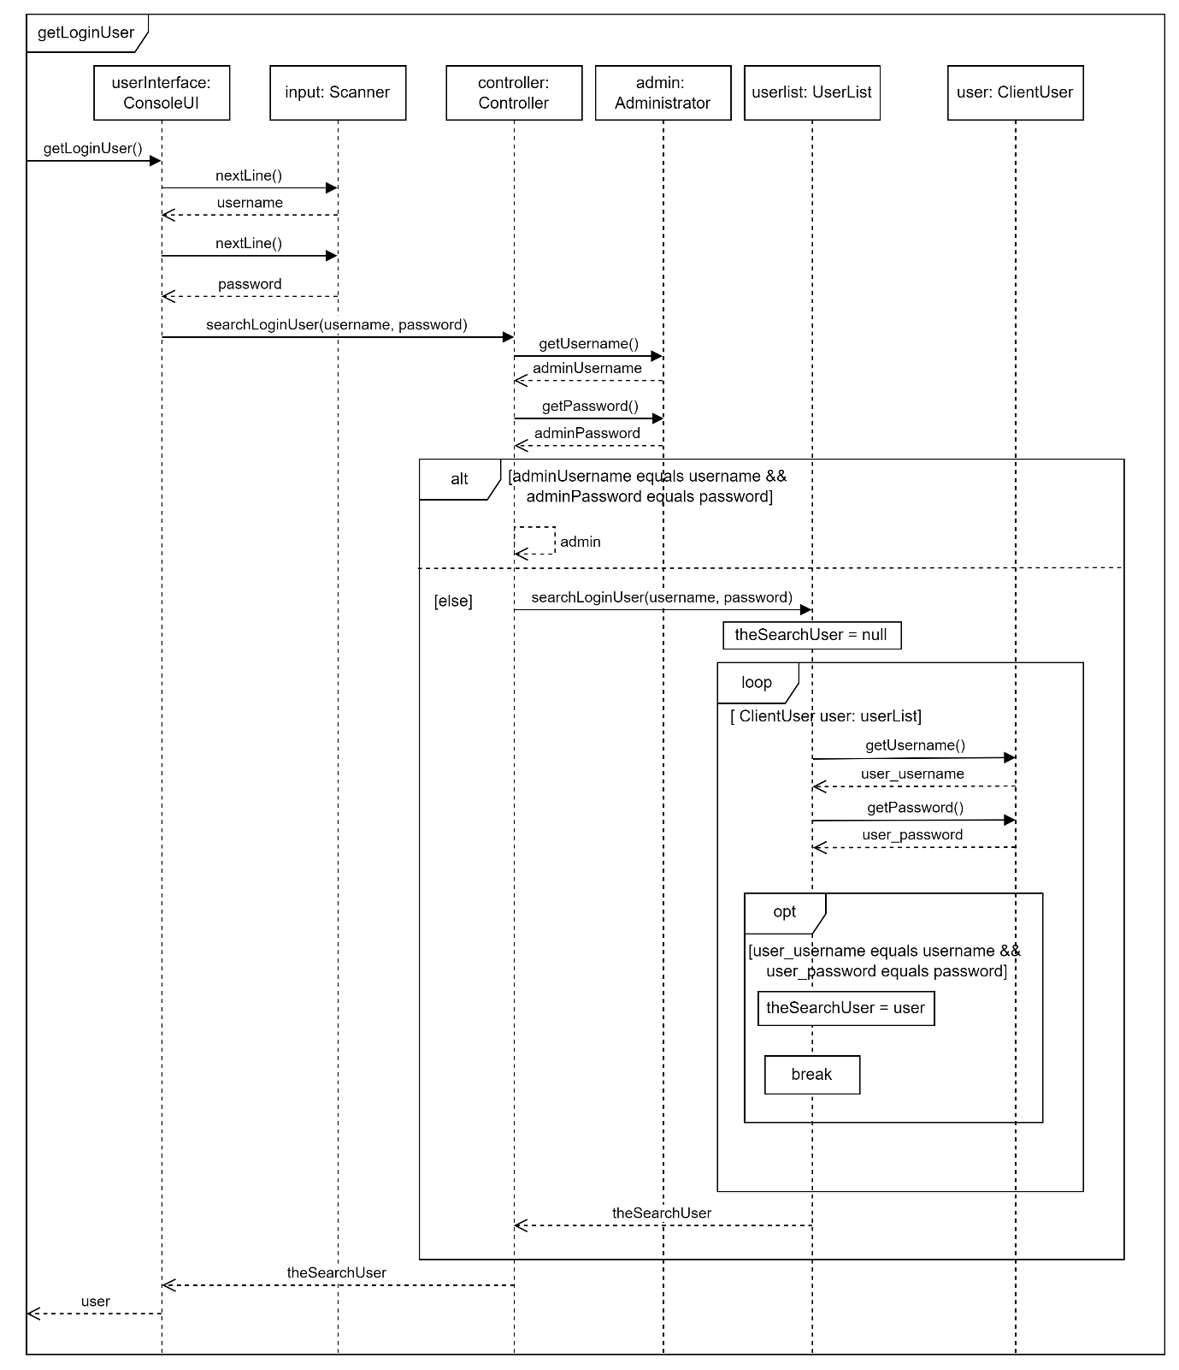

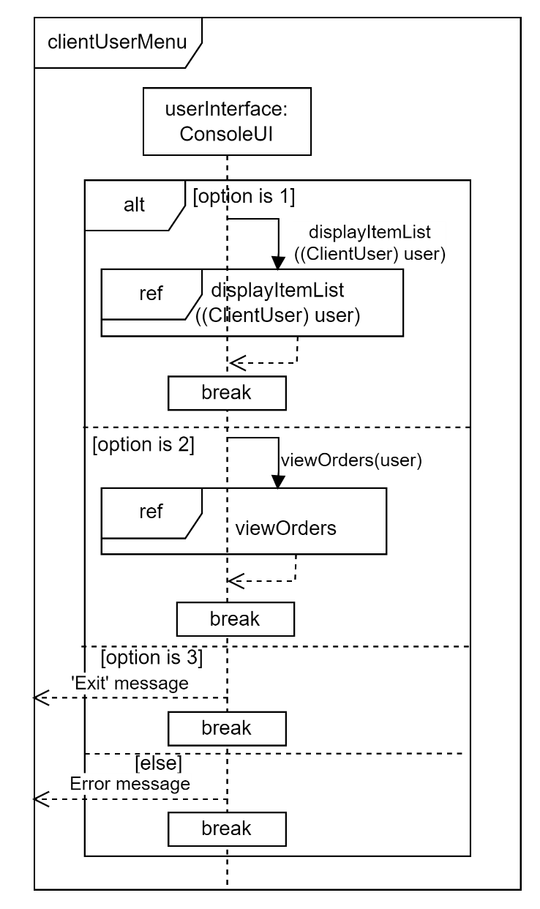

**Sequence Diagram**

## **UC02 Create Profile**

**Sequence Diagram**

## **UC03 View item list**

**Sequence Diagram**

## **UC04 Create order**

**Sequence Diagram**

## **UC05 View order**

**Sequence Diagram**

## **UC06 Update order**

**Sequence Diagram**

## **UC07 Make payment**

**Sequence Diagram**

## **UC08 Manage Item**

**Sequence Diagram**

## **UC09 Generate report**

## **Repeat Sequence Diagram Ref**

# **Design Class Diagram**

## **1st Version of Design Class Diagram**

## **2nd (Final) Version of Design Class Diagram**

(Will be attached **in ZIP file)**

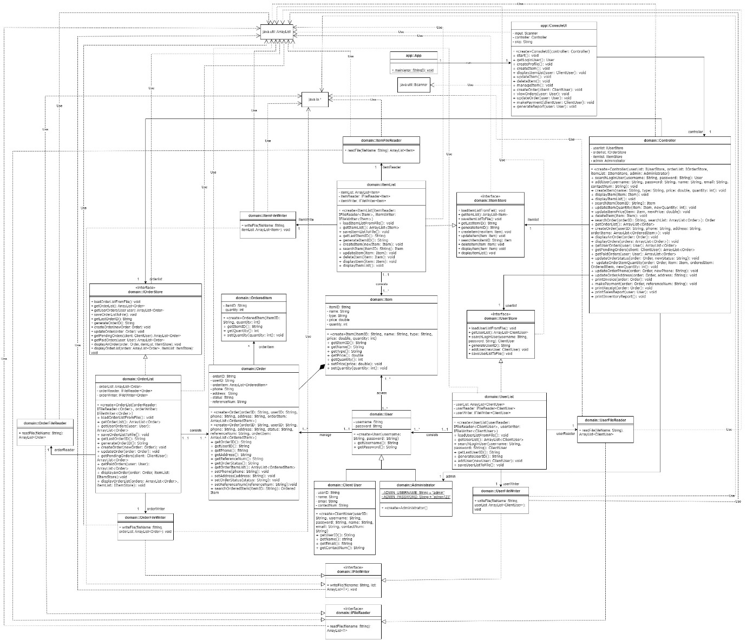

# **Package Diagram**

